Job 1

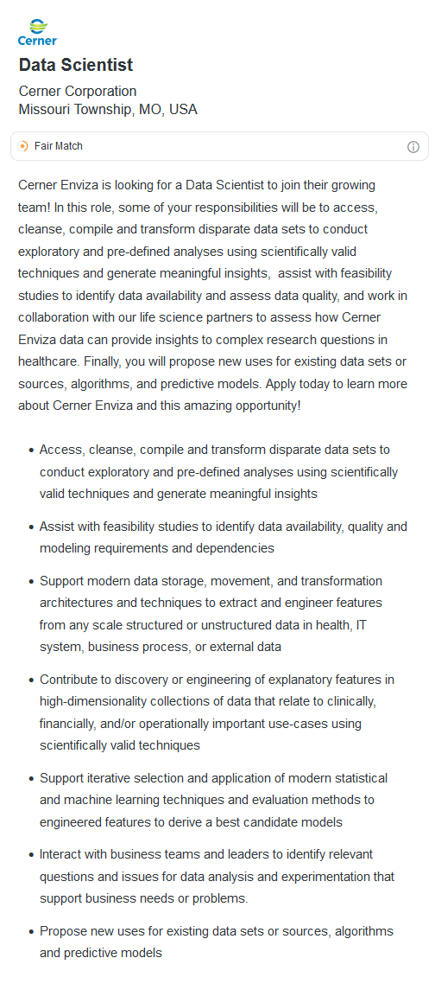

<https://sjobs-brassring.smart-apply-zr.com/TgNewUI/Search/Home/HomeWithPreLoad?partnerid=25754&siteid=5095&JobId=742464&PageType=jobdetails#jobDetails=742464_5095>

Cerner Enviza: Looking for a data analyst to manipulate healthcare related data that stems from research.

Job Description: Vast collection and manipulation of data. It would appear the majority of the job would be what we consider a “data analyst” should be, taking entire databases and completely manipulating it to make it both functional and presentable.

Requirements: Master’s degree and 6 years of work/school related experience. Must know Python (+ API) and/or SQL.

Job 2

<https://www.linkedin.com/jobs/view/data-analyst-entry-level-at-staffigo-3211481657/?currentJobId=-997439241.Retro>

Staffigo: IT consulting firm that cover various industries in healthcare, finance, and banking.

Job Description: With guidance, analyze data (which doesn’t seem to be traditional data, in the data is gathered from collecting information over various situations) and present data to help identify issues and to create solutions for such issues.

Requirements: Master’s degree and advanced EXCEL skills. Must know Power BI or Tableau.

Summary

The key points of both job descriptions are that you are required to collect, organize, and manipulate data in order to create a presentable product to provide to management and/or clients. For the first job, it appears you are expected to work independently and provide data towards management. For the second, you are to work with senior staff to provide data for clients. Both companies request a masters degree, and expect you to understand how to use specific programming. For job 1, you’re expected to have experience with Python (+ API) and/or SQL; while job 2 expects you to be familiar with Power Bi or Tableau.

Just from the requirements I would assume that job 1 is more related to coding/manipulating of data and job 2 is closer to the presentation of data. This makes sense as one is a consultation group while the other is more data analytical through research interpretation. I believe job 1 has more of a demand for a wide range of analytical skills in order to take data and funnel it into a database, then manipulate it so it is presentable. Taking raw data, manipulating it, and then presenting it seems to be the bread and butter of being analyst. Which is what they’re asking for here. While job 2 seems to be not as extreme and more geared to presentation, there is also verbiage indicating that you are not expected to work alone.

I do not believe I am even remotely capable enough for job 1. As I have only done 1 project in Tableau and I haven’t even begun really training in it, I also don’t believe I could make it in job 2. My knowledge is amateurish at best when it comes to Python and SQL. Both of quick I am taking specific courses geared to just these two subjects online. Perhaps if I could find an entry level position like job 2 for these two skills I might be confident in applying, but as I am now I do not feel remotely confident. EXCEL is where most of my experience comes from, but from the postings I’ve skimmed EXCEL is very limited in it uses outside of finance. Though I’m unsure if job 2’s EXCEL skills is finance related, I do feel confident with PIVOT tables and the like. Overall, I believe I lack the knowledge, skills, techniques, and experiences to readily apply for these positions. I don’t wish to be gloomy though, as I have yet to get half way through this degree and believe by the end of it I’ll be fully prepared to jump into entry level positions.